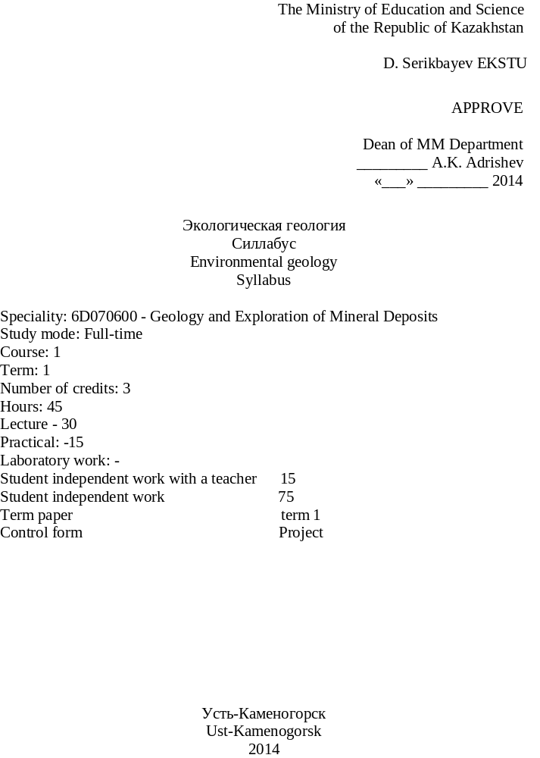
Syllabus developed at the department of "Geology and Mining" on the basis of the State educational standards (number) for students majoring 6D070600 - Geology and Exploration of Mineral Deposits.

Discussed at a meeting of the department "Geology and Mining"

Head of the Chair Z.Tungushbaeva

Protocol № __3__ by ____ .10.2014

Approved Training Methodology Council Mining and Metallurgical Faculty

Chairman G. Nurshaikova

Protocol № __1__ by _________, 2014

Developed by M. Mizernaya

NFORMATION FOR TEACHERS AND CONTACT INFORMATION

Department of "Geology and Mining" Mining and Metallurgical Faculty (off.G-3-413)
A teacher training: Mizernaya Marina, candidate of geological-mineralogical sciences, Head of the Chair .
Tel: 540-919
Contact hours and time for consultation: the schedule and timetable of the teacher.

- CHARACTERISTICS OF DISCIPLINE AND ITS PLACE IN THE EDUCATIONAL PROCESS

1.1 Description of the study subjects

The purpose of this course - meeting students from environmental geology.
This course gives an idea of the Earth as a "natural cosmic body", the composition and structure of the crust, the processes of internal and external dynamics of the Earth. Laid a general idea about the effects of geological processes and human activities on human life. Put the problems of human survival in conditions of scarcity of natural resources, the effects of hazardous geological processes.

1.2 Goals and objectives of the discipline

- The module - to provide basic knowledge of the environmental geology, structure of the lithosphere, the types of rocks, there origin and mode.
- To provide students with theoretical knowledge of the most important applied geological sciences: geology, environmental geology and hydrogeology - as a vast knowledge about life. The study of physical, mechanical and hydro-physical properties of rocks as a basis to assess their condition in mountain ranges;
- The study of environmental geology at different stages of mineral exploration and design of mining companies;
- The study of the origin, occurrence and formation;
- Introduction to the active control of groundwater and adverse geotechnical phenomena that the introduction of mechanization and automation in the mining industry is a major prerequisite for the success of modern mining facility.

1.3 Results of the discipline

Results: knowledge, skills and competences in the field of environmental geology assumes development of knowledge, skills and abilities.
Knowledge: the structure and properties of the Earth sphere;
Skills: Educational - know the basic processes of the formation of nature and anthropogenic processes;
Practical skills:
In the course of teaching the discipline necessary to teach students to "read" and analyze the state of the environment, making analysis of the mineral resources and developing their spoils.

1.4 Prerequisites

Prerequisites to apply disciplines: Fundamental geology, Chemistry, Physical and colloid chemistry

1.5 Post requisites

By post requisites include disciplines: diploma.

2 CONTENTS

2.1 Case Plan
Name of the topic, its content complexity | Part Suggested, o | References
Lectures
Topic 1 Environmental geology. Philosophy and fundamental concepts. Solving Environmental Problems, Difficult processes | 1 | Community -1-7  Extra – 1-4
Topic 2 Earth’s place in space | 1 | Community -1-7  Extra – 1-4
Topic 3 Human population growth | 1 | Community -1-7  Extra – 1-4
Topic 4 Sustainability. The death of Aral sea | 1 | Community -1-7  Extra – 1-4
Topic 5 Biodiversity | 1 | Community -1-7  Extra – 1-4
Topic 6 Earthquake Processes | 1 | Community -1-7  Extra – 1-3
Topic 7 Volcano Types. Volcanic Impact Risks | 1 | Community -1-7  Extra – 1-3
Topic 8 Streams and Rivers | 1 | Community -1-7  Extra – 1-3
Topic 9 Water pollution | 1 | Community -1-7  Extra – 3-4
Topic 10 Mineral Resources and Environment | 1
Topic11 Energy Resources | 1
Topic 12 Soils and Environment | 1
Topic 13 Global Climate Change | 1
Topic 14 Geology, Society, and the Future | 2
Topics labs and training
1 Earth’s place in space | 3 | Community -1-7  Extra – 2
2 Human population growth | 3 | Community -1-7  Extra – 2
3 Sustainability. The death of Aral sea | 3 | Community -1-7  Extra – 1-3
4 Biodiversity | 3 | Community -1-7  Extra – 1-3
5 Introduction to Natural Hazards |  | Community -1-7  Extra – 1-3
6 Earthquake Processes | 3 | Community -1-7  Extra – 1-3
7 Volcano Types. Volcanic Impact Risks | 3 | Community -2-3 Extra – 4
8 Streams and Rivers | 3 | Community -1-7  Extra – 3-4
9 Water pollution | 3 | Community -1-7  Extra – 3-4
10 Mineral Resources and Environment | 3 | Community -1-7  Extra – 3-4
11 Energy Resources | 3 | Community -1-7  Extra – 3-4
12 Soils and Environment | 3 | Community -1-7  Extra – 3-4
13 Global Climate Change | 3 | Community -1-7  Extra – 3-4
14 Geology, Society, and the Future | 6 | Community -1-7  Extra – 3-4
Self study time of the student
Environmental geology. Philosophy and fundamental concepts. Solving Environmental Problems, Difficult processes | 1 | Community -1-4  Extra – 1-3
Earth’s place in space | 1 | Community -1-4  Extra – 1-3
Human population growth | 1 | Community -1-4  Extra – 1-3
Sustainability. The death of Aral sea | 1 | Community -1-4  Extra – 1-3
Biodiversity | 1 | Community -1-4  Extra – 1-3
Introduction to Natural Hazards | 1 | Community -1-4  Extra – 1-3
Earthquake Processes | 1 | Community -1-4  Extra – 1-3
Volcano Types. Volcanic Impact Risks | 1 | Community -1-4  Extra – 1-3
Streams and Rivers | 1 | Community -1-4  Extra – 1-3
Water pollution | 1 | Community -1-7  Extra – 4
Mineral Resources and Environment | 1 | Community -1-7  Extra – 4
Energy Resources | 1 | Community -1-7  Extra – 4
Soils and Environment | 1 | Community -1-7  Extra – 4
Global Climate Change | 1 | Community -1-7  Extra – 4

2.2 Tasks for independent work (TIW)

Topic | The purpose and contents of the task | Recommended reading, references | Execution time, weeks | Form of control | Deadline, a week
Topic 1. Fundamentals of Environmental geology. A glossary | Familiarity with special terminology, practice skills in the use of terms | Community -1-7  Extra – 1-4 | 1 | dictation | 1
Topic 2: Case History: Island of Hispaniola | Familiarity with special terminology, practice skills in the use of terms | Community -1-7  Extra – 1-4 | 2 | recitation | 2
Topic 3 Case History: Two Major CA Cities | Obtain skills dynamic calculations | Community -1-7  Extra – 1-4 | 3 | recitation | 3
Topic 4 What is an Ecosystem? | Study of the basic methods | Community -1-7  Extra – 1-4 | 4 | recitation | 4
Topic 5: Case History: Endangered Trout | View presentations on major terrestrial m underground drainage methods | Community -1-7  Extra – 1-4 | 5 | recitation | 5
Topic 6: Geological time dimension | Key concepts of the section | Community -1-7  Extra – 1-4 | 6 | recitation | 6
Topic 7 Critical-Thinking Topics Assume the Pangaea never broke up, how might today’s environments be different? | Test your knowledge of the conceptual apparatus, line engineering geology | Community -1-7  Extra – 1-4 | 7 | recitation | 7
Topic 8 Plate Tectonics | quiz | Community -1-7  Extra – 1-4 | 8 | presentation | 8
Topic 9 Case History: Hurricane Katrina | Summarizing the outcomes of knowledge on the course | Community -1-7  Extra – 1-4 | 9 | presentation | 9
Topic 10 Ecosystems |  | Community -1-7  Extra – 1-4 | 10 | presentation | 10
Topic 11 Biodiversity |  | Community -1-7  Extra – 1-4 | 11 | presentation | 11
Topic 12 Case History: Earthquake |  | Community -1-7  Extra – 1-4 | 12 | presentation | 12
Topic 13 Earthquake Processes |  | Community -1-7  Extra – 1-4 | 13 | presentation | 13
Topic 14 Composite or Stratovolcano |  | Community -1-7  Extra – 1-4 | 14 | presentation | 14
Topic 15 Streams and Rivers |  | Community -1-7  Extra – 1-4 | 15 | presentation | 15

2.4 Timetable for implementation and delivery of jobs by discipline *

Type of control | Academic training period, week
Type of control | 1 | 2 | 3 | 4 | 5 | 6 | 7 | 8 | 9 | 10 | 11 | 12 | 13 | 14 | 15
Attendance | * | * | * | * | * | * | * | * | * | * | * | * | * | * | 10
Lecture notes |  |  |  |  |  |  |  |  |  | * |  |  |  |  | 10
Recitation | * | * | * | * | * | * | * | * | * | * | * | * | * | * | 10
Colloquium |  |  | * |  |  |  | * |  |  |  |  | * |  |  | 30
Pinging

Abstract

Essay |  |  |  | * |  |  |  |  |  |  |  | * |  |  | 20
Borderline |  |  |  |  |  |  | * |  |  |  |  |  |  | * | 20
Summery |  |  |  |  |  |  |  |  |  |  |  |  |  |  | 100

- REFERENCES

- Community

- Bell F.G. A Environmental geology PDF Second edition. Elsevier Linacre House, Jordan Hill, Oxford OX2 8DP, UK, 30 Corporate Drive, Suite 400, Burlington, MA 01803, USA, 2007. 593 p. ISBN-13: 978-0-7506-8077-6; ISBN-10: 0-7506-8077-6
- Klimchouk, A.B.. Hypogene Speleogenesis: Hydrogeological and Morphogenetic Perspective. Special Paper no.1, National Cave and Karst Research Institute, 2007 Carlsbad, NM, 106 pp.
- Peng S. , Zhang J. , Engineering Geology for Underground Rocks. Издательство:Springer. Год: 2007. ISBN: 3540732942.
- Price David George. Engineering geology - principles and practice PDF ISBN: 978-3-540-29249-4 Library of Congress Control Number: 2008937486 © 2009 Springer-Verlag.
- Montgomery. Environmental geology. McGraw-Hill/Mcgraw hill higher education. 2010/03/01
- G. Nelson Eby Principles of environmental geochemistry ISBN: 955-3-678-39249-3 Library of Congress Control Number
- Gunter Faure Principles and applications of geochemistry. Elsevier Linacre House, Jordan Hill, Oxford OX2 8DP, UK, 30 Corporate Drive, Suite 400, Burlington

3.2 Extra

- Денисов Н.Я. Инженерная геология и гидрогеология.- М.: Госстройиздат,2004.
- Ланге О.К. Основы геологии .-Изд. Моск. Унив.,2001.-224 с.
- Earth:An Introduction to Physical Geology: International Edition, Tarbuck Edward,
Pearson Education/Pearson education (us)
4. Economic Geology Pohl Walter L Wiley-Blackwell, 05.04.2011, 680, 9781444336634

4 EVALUATION OF KNOWLEDGE

  - Teacher’s Requirements

Teacher’s Requirements:
- Visiting lectures and seminars schedule is required;
- The presence of students in the classroom is checked at the beginning of class. In case of delay the student must enter quietly into the audience and to engage in work, and at half-time teacher to explain the cause of delay;
- Two late to class count as one of absenteeism;
- Measured on a scale of work should be submitted on time. For the late submission of the work points decreases. Students who do not pass all the tasks, the exam is not permitted;
- Repeated passage of a landmark student control in the event of unsatisfactory performance evaluation is not permitted;
- Students with average RFA = (P1 + P2) / 2 is less than 50%, the exam is not permitted;
- During lessons mobile phones must be turned off;
- The student is required to attend classes in business clothes.

  - Evaluation Criteria

Evaluation of all types of tasks performed on a 100-point scale.
Monitoring is carried out every week and includes monitoring attendance at lectures, workshops and performs independent work.
Boundary line of control knowledge is held at 7 and 15 weeks of the semester in various forms: test, dictation, recitation. Rating formed the basis of the following types of control*:

Qualification test period | Type of control, %
Qualification test period | Attendance | Lecture notes | Recitation | Colloquium | Pinging | Abstract | Essay | Borderline test | Summery
1 | 5 | 5 | 10 | 5 | 15 | 5 | 5 | 50 | 100
2 | 5 | 5 | 5 | 5 | 15 | 5 | 10 | 50 | 100

The exam is held in the discipline during the examination session in the form of testing:
- 40% the result obtained in the exam;
60% of the results of the current progress.
Formula for calculating the final grade:
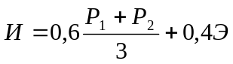, (1)

where P1, P2 - digital equivalents estimates first, second ratings, respectively;
Э - the digital equivalent of assessment on the exam.

The final character assessment and its digital equivalent in points:

Evaluation  by alphabetic system | Digital equivalent points | Percentage,% | evaluation  the traditional  system
А | 4,0 | 95–100 | excellent
А– | 3,67 | 90–94 | excellent
В+ | 3,33 | 85–89 | good
В | 3,0 | 80–84 | good
В– | 2,67 | 75–79 | good
С+ | 2,33 | 70–74 | satisfactorily
С | 2,0 | 65–69 | satisfactorily
С– | 1,67 | 60–64 | satisfactorily
D+ | 1,33 | 55–59 | satisfactorily
D | 1,0 | 50–54 | satisfactorily
F | 0 | 0–49 | unsatisfactorily

